**EXPERIMENT 3 Date: 27th January 2023**

**TITLE:** **DDL (Data Definition Language) commands with Data Constraints**

**Objective:** To understand the concept of data constraints that is enforced on data being stored in the table. Focus on Primary Key and the Foreign Key

**CREATE THE TABLES DESCRIBED BELOW:**

1. **Table name: CLIENT_MASTER_1**

**Description:** use to store client information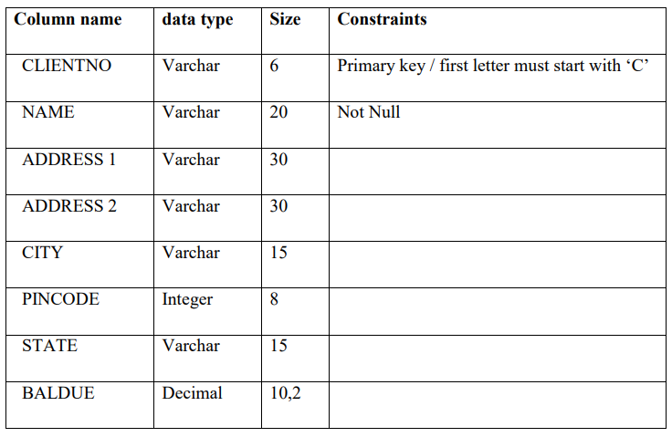

**Query:**

CREATE TABLE CLIENT_MASTER_1(

CLIENTNO VARCHAR (6),

NAME VARCHAR(20) NOT NULL,

ADDRESS1 VARCHAR (30),

ADDRESS2 VARCHAR (30),

CITY VARCHAR (15),

PINCODE INTEGER(8),

STATE VARCHAR (15),

BALDUE DECIMAL (10,2),

PRIMARY KEY (CLIENTNO),

CHECK (CLIENTNO LIKE 'C%')

);

DESC CLIENT_MASTER_1;

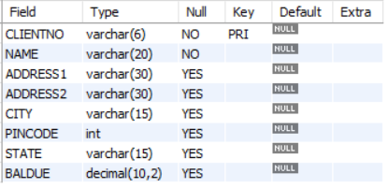

1. **Table Name: PRODUCT_MASTER_1**

**Description:** used to store product information

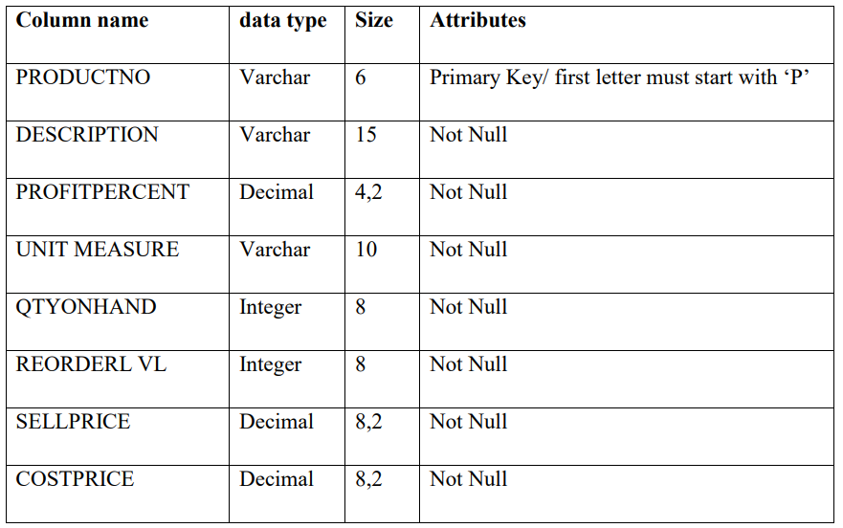

**Query:**

CREATE TABLE PRODUCT_MASTER_1(

PRODUCTNO VARCHAR (6),

DESCRIPTION VARCHAR(15) NOT NULL,

PROFIT_PERCENT DECIMAL (4,2) NOT NULL,

UNIT_MEASURE VARCHAR (10) NOT NULL,

QTY_ON_HAND INTEGER(8) NOT NULL,

REORDERL_VL INTEGER(8) NOT NULL,

SELLPRICE DECIMAL(8,2) NOT NULL,

COST_PRICE DECIMAL(8,2) NOT NULL,

PRIMARY KEY (PRODUCTNO),

CHECK (PRODUCTNO LIKE 'P%')

);

DESC PRODUCT_MASTER_1;

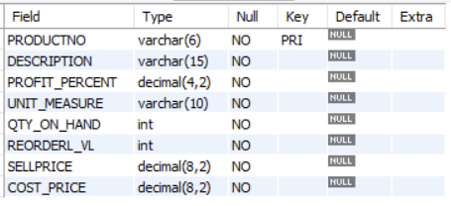

1. **Table Name: SALESMAN_MASTER _1**

**Description:** used to store salesman information working for the company

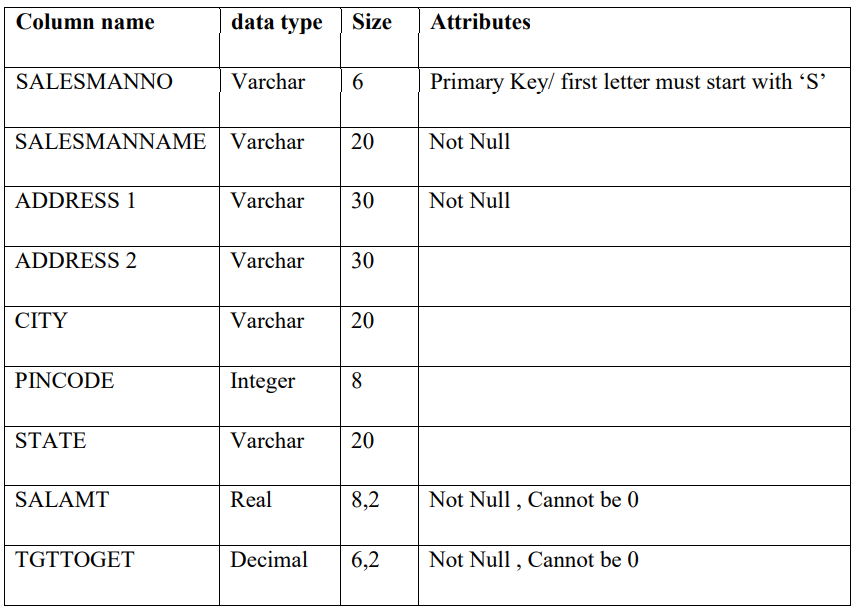

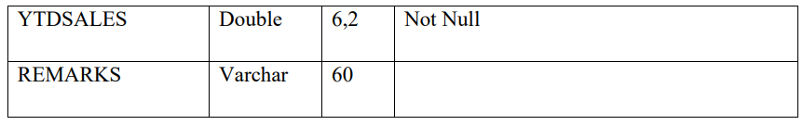

**Query:**

CREATE TABLE SALESMAN_MASTER_1(

SALESMANNO VARCHAR (6),

SALESMANNAME VARCHAR(20) NOT NULL,

ADDRESS1 VARCHAR(30) NOT NULL,

ADDRESS2 VARCHAR(30),

CITY VARCHAR (20),

PINCODE INTEGER(8),

STATE VARCHAR (20),

SALAMT REAL(8,2) NOT NULL CHECK(SALAMT!=0),

TGTTOGET DECIMAL(6,2) NOT NULL CHECK(TGTTOGET!=0),

YTDSALES DOUBLE(6,2) NOT NULL,

REMARKS VARCHAR (60),

PRIMARY KEY (SALESMANNO),

CHECK (SALESMANNO LIKE 'S%')

);

DESC SALESMAN_MASTER_1;

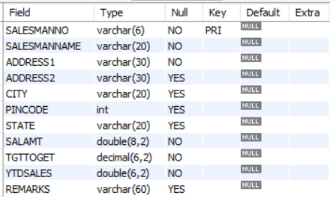

**REINSERT THE DATA IN THESE TWO TABLES BASED UPON LAB 1**

1. **Table name: CLIENT_MASTER_1**

INSERT INTO CLIENT_MASTER_1 VALUES("C00001", "Ivan bayross", NULL, '', "Mumbai", 400054, "Maharashtra", 15000);

INSERT INTO CLIENT_MASTER_1(CLIENTNO, NAME, CITY, PINCODE, STATE, BALDUE) VALUES("C00002", "Mamta muzumdar", "Madras", 780001, "Tamil nadu", 0);

INSERT INTO CLIENT_MASTER_1(CLIENTNO, NAME, CITY, PINCODE, STATE, BALDUE) VALUES('C00003', 'Chhaya bankar', 'Mumbai', 400057, 'Maharashtra', 5000);

INSERT INTO CLIENT_MASTER_1(CLIENTNO, NAME, CITY, PINCODE, STATE, BALDUE) VALUES('C00004', 'Ashwini joshi', 'Bangalore', 560001, 'Karnataka', 0);

INSERT INTO CLIENT_MASTER_1(CLIENTNO, NAME, CITY, PINCODE, STATE, BALDUE) VALUES('C00005', 'Hansel colaco', 'Mumbai', 400060, 'Maharashtra', 2000);

INSERT INTO CLIENT_MASTER_1(CLIENTNO, NAME, CITY, PINCODE, STATE, BALDUE) VALUES('C00006', 'Deepak sharma', 'Mangalore', 560050, 'Karnataka', 0);

1. **Table Name: PRODUCT_MASTER_1**

INSERT INTO PRODUCT_MASTER_1 VALUES('P00001', 'T-Shirt', 5, 'Piece', 200, 50, 350, 250);

INSERT INTO PRODUCT_MASTER_1 VALUES('P0345', 'Shirts', 6, 'Piece', 150, 50, 500, 350);

INSERT INTO PRODUCT_MASTER_1 VALUES('P06734', 'Cotton jeans', 5, 'Piece', 100, 20, 600, 450);

INSERT INTO PRODUCT_MASTER_1 VALUES('P07865', 'Jeans', 5, 'Piece', 100, 20, 750, 500);

INSERT INTO PRODUCT_MASTER_1 VALUES('P07868', 'Trousers', 2, 'Piece', 150, 50, 850, 550);

INSERT INTO PRODUCT_MASTER_1 VALUES('P07885', 'Pull Overs', 2.5, 'Piece', 80, 30, 700, 450);

INSERT INTO PRODUCT_MASTER_1 VALUES('P07965', 'Denim jeans', 4, 'Piece', 100, 40, 350, 250);

INSERT INTO PRODUCT_MASTER_1 VALUES('P07975', 'Lycra tops', 5, 'Piece', 70, 30, 300, 175);

INSERT INTO PRODUCT_MASTER_1 VALUES('P08865', 'Skirts', 5, 'Piece', 75, 30, 450, 300);

1. **Table Name: SALESMAN_MASTER _1**

INSERT INTO SALESMAN_MASTER_1 VALUES('S00001', 'Aman', 'A/14', 'Worli', 'Mumbai', 400002, 'Maharashtra', 3000, 100, 50, 'Good');

INSERT INTO SALESMAN_MASTER_1 VALUES('S00002', 'OMKAR', '65', 'NARIMAN', 'Mumbai', 400002, 'Maharashtra',3000, 200, 100, 'Good');

INSERT INTO SALESMAN_MASTER_1 VALUES('S00003', 'RAJ', 'P-7', 'BANDRA', 'Mumbai', 400032, 'Maharashtra',3000, 200, 100, 'Good');

INSERT INTO SALESMAN_MASTER_1 VALUES('S00004', 'ASHISH', 'A/5', 'JUHU', 'Mumbai', 400044, 'Maharashtra',3000, 200, 150, 'Good');

1. **Display the contents of each table.**

SELECT * FROM CLIENT_MASTER_1;

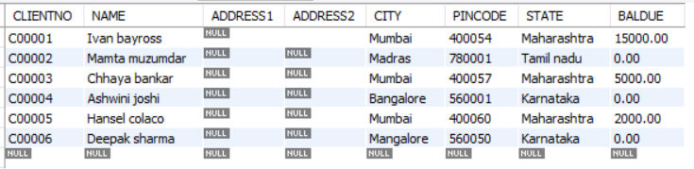

SELECT * FROM PRODUCT_MASTER_1;

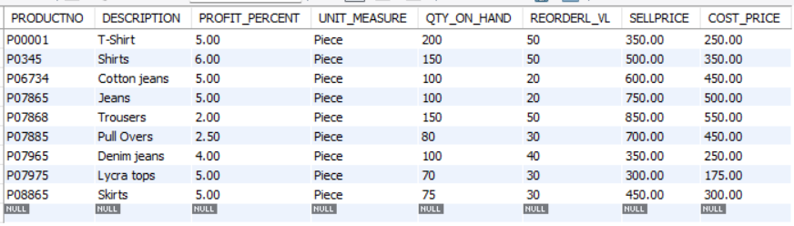  
SELECT * FROM SALESMAN_MASTER_1;

